-argentina não tem dados eleitorais

- brasil PT= 10,6% da amostra

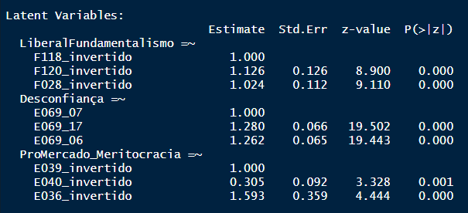

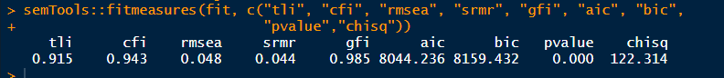

|  |  |  |  |  |
| --- | --- | --- | --- | --- |
|  | PT_ | PT_ | PT_ | PT_ |
| Predictors | Odds Ratios | Odds Ratios | Odds Ratios | Odds Ratios |
| (Intercept) | 0.08 *** (0.05) | 0.11 *** (0.01) | 0.15 *** (0.03) | 0.10 ** (0.08) |
| Gender | 0.97  (0.17) |  |  | 1.08  (0.20) |
| X049 | 1.14 ** (0.06) |  |  | 1.13 * (0.06) |
| raca_brancTRUE | 1.16  (0.23) |  |  | 1.05  (0.23) |
| idade_faixa | 0.69 ** (0.09) |  |  | 0.82  (0.12) |
| escolaridade_niveis | 1.27  (0.18) |  |  | 0.89  (0.14) |
| status_emploSelf Employed | 0.74  (0.21) |  |  | 0.70  (0.21) |
| status_emploHousewife | 0.44 ** (0.13) |  |  | 0.50 * (0.16) |
| status_emploRetired | 0.39  (0.19) |  |  | 0.41  (0.21) |
| status_emploStudent | 1.03  (0.37) |  |  | 1.02  (0.40) |
| status_emploOthers | 1.29  (0.25) |  |  | 1.19  (0.24) |
| rend_subjLow | 0.90  (0.29) |  |  | 0.99  (0.35) |
| rend_subjMedium | 0.92  (0.33) |  |  | 0.86  (0.33) |
| rend_subjHigh | 0.88  (0.46) |  |  | 0.69  (0.39) |
| religionCatholic | 0.89  (0.20) |  |  | 1.25  (0.31) |
| religionOther Christian (Evangelical/Pentecostal) | 0.46  (0.22) |  |  | 0.88  (0.44) |
| religionOthers | 1.06  (0.31) |  |  | 1.18  (0.37) |
| fundamentalism |  | 0.02 *** (0.02) | 0.07 ** (0.06) | 0.09 ** (0.08) |
| desconfia |  | 4.40 * (2.56) | 2.16  (1.35) | 1.95  (1.26) |
| promercado |  | 0.18 * (0.16) | 0.15 * (0.14) | 0.22  (0.21) |
| autoloc_dir_esqCenter |  |  | 0.27 *** (0.06) | 0.29 *** (0.06) |
| autoloc_dir_esqRight |  |  | 0.17 *** (0.04) | 0.19 *** (0.04) |
| autoloc_dir_esqDon't Know |  |  | 0.16 *** (0.06) | 0.19 *** (0.07) |
| interesse |  |  | 3.62 *** (0.88) | 3.71 *** (0.97) |
| Observations | 1782 | 1782 | 1774 | 1774 |
| R2 Tjur | 0.041 | 0.031 | 0.129 | 0.147 |
| * p<0.05   ** p<0.01   *** p<0.001 | | | | |

#

Chile – Democracia Cristiana (DC) 45,8%

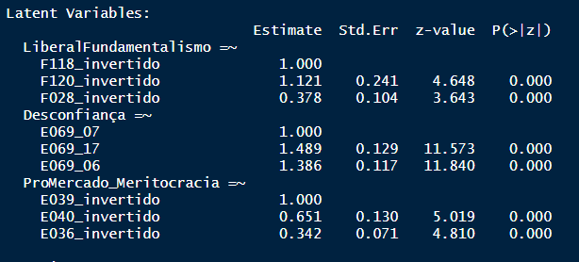

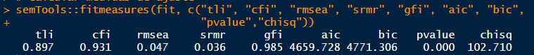

|  |  |  |  |  |
| --- | --- | --- | --- | --- |
|  | DC_ | DC_ | DC_ | DC_ |
| Predictors | Odds Ratios | Odds Ratios | Odds Ratios | Odds Ratios |
| (Intercept) | 0.11 * (0.11) | 0.84 ** (0.04) | 0.93  (0.13) | 0.11 * (0.12) |
| Gender | 0.92  (0.12) |  |  | 1.03  (0.14) |
| X049 | 1.37 * (0.19) |  |  | 1.35 * (0.19) |
| raca_brancTRUE | 0.98  (0.26) |  |  | 0.95  (0.25) |
| idade_faixa | 1.02  (0.08) |  |  | 1.04  (0.09) |
| region152003 | 0.41 * (0.15) |  |  | 0.42 * (0.16) |
| region152004 | 0.70  (0.28) |  |  | 0.77  (0.32) |
| region152005 | 0.64  (0.34) |  |  | 0.61  (0.33) |
| region152006 | 0.82  (0.24) |  |  | 0.85  (0.25) |
| region152007 | 0.73  (0.30) |  |  | 0.71  (0.30) |
| region152008 | 0.31 ** (0.14) |  |  | 0.31 ** (0.14) |
| region152010 | 0.87  (0.30) |  |  | 0.87  (0.31) |
| region152012 | 1.14  (0.42) |  |  | 1.35  (0.51) |
| region152014 | 0.47 * (0.15) |  |  | 0.50 * (0.16) |
| region152016 | 0.73  (0.21) |  |  | 0.76  (0.22) |
| status_emploSelf Employed | 1.29  (0.22) |  |  | 1.32  (0.23) |
| status_emploHousewife | 1.11  (0.19) |  |  | 1.06  (0.18) |
| status_emploRetired | 0.89  (0.21) |  |  | 0.94  (0.22) |
| status_emploStudent | 0.91  (0.20) |  |  | 0.92  (0.21) |
| status_emploOthers | 0.89  (0.16) |  |  | 0.88  (0.16) |
| rend_subjDK | 0.28 * (0.14) |  |  | 0.29 * (0.15) |
| rend_subjLow | 1.48 * (0.24) |  |  | 1.50 * (0.26) |
| rend_subjMedium | 1.28  (0.19) |  |  | 1.24  (0.19) |
| religionCatholic | 1.29  (0.19) |  |  | 1.26  (0.19) |
| religionOthers | 0.76  (0.15) |  |  | 0.73  (0.15) |
| fundamentalism |  | 3.48 * (2.02) | 4.25 * (2.51) | 4.08 * (2.51) |
| desconfia |  | 0.61  (0.29) | 0.65  (0.31) | 0.61  (0.30) |
| promercado |  | 1.02  (0.29) | 1.02  (0.29) | 0.90  (0.26) |
| autoloc_dir_esqCenter |  |  | 1.04  (0.15) | 1.05  (0.15) |
| autoloc_dir_esqRight |  |  | 0.86  (0.13) | 0.85  (0.13) |
| autoloc_dir_esqDon't Know |  |  | 0.52 ** (0.10) | 0.50 *** (0.10) |
| interesse |  |  | 1.03  (0.17) | 1.08  (0.19) |
| Observations | 1499 | 1500 | 1494 | 1493 |
| R2 Tjur | 0.035 | 0.005 | 0.017 | 0.051 |
| * p<0.05   ** p<0.01   *** p<0.001 | | | | |

#

México

Partido + citado: PRI (34,68 % da amostra)

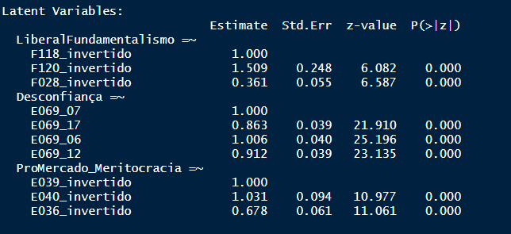

> semTools::fitmeasures(fit, c("tli", "cfi", "rmsea", "srmr", "gfi", "aic", "bic",

+ "pvalue","chisq"))

tli cfi rmsea srmr gfi aic bic pvalue chisq

0.970 0.979 0.036 0.037 0.988 4805.884 4928.558 0.000 93.883

|  |  |  |  |  |
| --- | --- | --- | --- | --- |
|  | PRI_ | PRI_ | PRI_ | PRI_ |
| Predictors | Odds Ratios | Odds Ratios | Odds Ratios | Odds Ratios |
| (Intercept) | 1.50  (0.64) | 0.51 *** (0.03) | 0.29 *** (0.06) | 0.89  (0.45) |
| Gender | 0.79  (0.10) |  |  | 0.77  (0.11) |
| X049 | 0.85 *** (0.03) |  |  | 0.86 *** (0.03) |
| raca_brancTRUE | 0.94  (0.14) |  |  | 0.86  (0.13) |
| idade_faixa | 1.14  (0.10) |  |  | 1.16  (0.10) |
| status_emploSelf Employed | 0.62 ** (0.11) |  |  | 0.66 * (0.13) |
| status_emploHousewife | 1.07  (0.20) |  |  | 1.00  (0.20) |
| status_emploStudent | 0.70  (0.14) |  |  | 0.65 * (0.13) |
| status_emploOthers | 0.71 * (0.11) |  |  | 0.71 * (0.12) |
| rend_subjDK | 1.54  (0.51) |  |  | 1.84  (0.66) |
| rend_subjLow | 0.72  (0.18) |  |  | 0.88  (0.24) |
| rend_subjMedium | 0.77  (0.19) |  |  | 0.92  (0.25) |
| religionCatholic | 2.03 *** (0.35) |  |  | 1.51 * (0.28) |
| religionOthers | 1.37  (0.39) |  |  | 1.14  (0.34) |
| fundamentalism |  | 1.25  (0.44) | 0.94  (0.35) | 0.67  (0.26) |
| desconfia |  | 0.08 *** (0.02) | 0.10 *** (0.03) | 0.11 *** (0.03) |
| promercado |  | 1.58  (0.56) | 1.47  (0.54) | 1.18  (0.45) |
| autoloc_dir_esqCenter |  |  | 2.25 *** (0.47) | 2.12 *** (0.45) |
| autoloc_dir_esqRight |  |  | 3.29 *** (0.66) | 3.20 *** (0.65) |
| autoloc_dir_esqDon't Know |  |  | 1.48  (0.34) | 1.33  (0.32) |
| interesse |  |  | 0.59 * (0.12) | 0.62 * (0.13) |
| Observations | 1531 | 1531 | 1486 | 1486 |
| R2 Tjur | 0.049 | 0.062 | 0.098 | 0.131 |
| * p<0.05   ** p<0.01   *** p<0.001 | | | | |

#

final

Tabela – onda 2 – resultados da análise fatorial confirmatória

ver tabelas resultados analise fatorial confirmatoria.xlsx